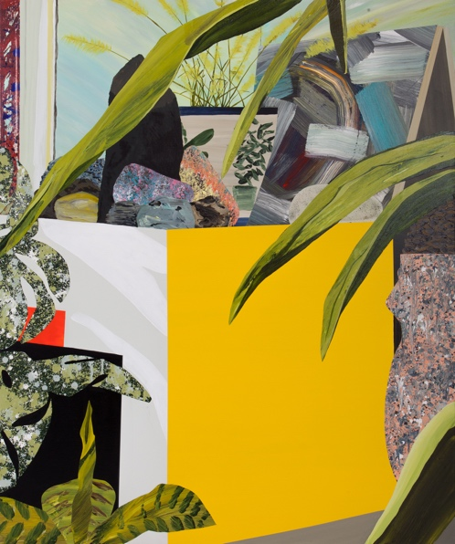**Paul Wackers**

*Early Settlers*

May 11 – June 17, 2017

Opening reception:

Thursday, May 11, 6 – 8pm

Morgan Lehman Gallery is pleased to present *Early Settlers*, Paul Wackers’ third solo show with the gallery.

Paul Wackers’ work provides a glimpse into an intimate world, where objects and abstractions coalesce into personal and historical narratives. Through the juxtaposition of natural and synthetic textures and objects both mundane and iconic, Wackers’ work acts as both a record of his own domestic routine and surroundings, and as a lens into collective human experience and historical change.  Here the everyday and the universal find equal footing in their distillation into singular, evocative artifacts.

For Wackers, the title *Early Settlers* reflects exploration into uncharted territory. These works chronicle a personal and social search for new anchors, networks, and connections amidst a vast and chaotic unknown. Landscapes of irregular perspectives, fragmented objects, and enigmatic rooms present unexpected barriers to entry and understanding. Here is a fully contemporary world, wherein changes in the global political and social climate call into question even the most mundane details of life. The objects are everyday, but when re-contextualized in ambiguous settings, they suggest instability, separation, and uncertainty.

These environments, though, are by no means closed off or hopeless. A persistent sense of playfulness reminds us of the moments of joy in the everyday. In many cases, the presence of the natural world offers access to spaces of calm--a clearing in the dark woods, a literal or metaphorical light--and the continued existence of both physical and mental solace is reaffirmed, even if hope feels momentarily out of reach.

Paul Wackers was born in New Haven, Connecticut in 1978. He graduated with his BFA from Corcoran College of Art and Design in Washington, DC with a degree in Fine Arts, and earned his MFA in Paintings from the San Francisco Art Institute. Wackers has exhibited nationally and internationally in Belgium, Denmark, Canada, Peru, San Francisco, CA, Los Angeles, CA, and New York, NY.

He completed a large-scale public mural for The James Hotel (New York, NY) and has been featured in Paper Magazine, Hyperallergic, Juxtapoz, New American Painting, and Art Practical. He was a visiting artist lecturer at Brooklyn College, and has participated in residencies at Byrdcliffe Guild (Woodstock, NY) and the Nordic Artist’s Centre Dale (Sunnfjord, Norway). In 2009, he won the Tournesol Award from the Headlands Center for the Arts (Sausalito, CA), and was a SECA award finalist.

His work is held in numerous private and public collections, including the Chevron Corporation (San Ramon, CA), Fidelity Investments (Boston, MA), Wellington Management (Boston, MA), New York Presbyterian Hospital (New York, NY), University of Texas Southwest Medical Center (Dallas, TX), and the West Collection (Oaks, PA).

Image: *Yellow Belly,* 2017, acrylic on canvas, 60 x 50 in (152.40 x 127 cm)