Nathan Randall Green
Light Field

September 9 – October 16, 2021

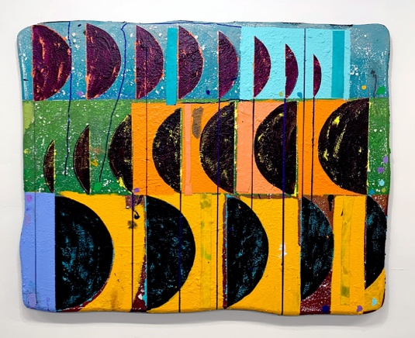

Morgan Lehman Gallery is pleased to present Light Field, an exhibition of new paintings by Nathan Randall Green. This marks the artist’s first solo exhibition with the gallery.
The inspiration behind the Green’s latest body of work is born of looking out and up, contemplating the cosmological. The artist is drawn to the powerful sense of awe associated with stargazing and meditating on metaphysical concepts. Black holes, white dwarfs, cosmic inflammation and parallel universes are all highly abstract ideas that Green processes, interprets, and expresses through the act of painterly abstraction. The resulting paintings function as schematic diagrams that attempt to give visual life to these theoretical cosmological events, imbuing them with a sense of playful curiosity. In building his pictorial worlds, Green deploys recognizable symbols such as crescents, radiant lines, and solar symbols, which he then scrambles, reimagines, and reconfigures.
Over the past several years, the artist has developed a signature material approach that incorporates paper pulp, acrylic, collage, ink, graphite, and collage on canvas. Green is interested in the visual intrigue of irregularity and texture: he intentionally forms his painting supports into quirky, asymmetrical shapes that resist the classic rectangle of the image plane and instead insist on a certain exaggerated physicality. After laboriously preparing and priming his surfaces, the artist proceeds by drawing in graphite or ink directly onto the canvas. Green then often abandons his initial plan, preferring to let the intuitive process of making inform his approach to form, color, and composition, welcoming the incidental marks that inevitably come along the way.
Green’s brand of hard-edge geometric abstraction explores the tension that occurs by layering crisp graphic information on top of textured, imperfect surfaces and substrates with comically organic forms. The paintings are both serious and giddy with wonder. For this body of work, Green committed to a landscape orientation in order to situate the viewer in a specific “place”, asking them to look into, and then perhaps up and beyond.

Nathan Randall Green was born in Houston, Texas, and received his B.F.A. from the University of Texas at Austin. He is a founding member and partner of Okay Mountain Gallery and Collective in Austin, Texas and was a Curator of Education at the Modern Art Museum of Fort Worth (TX). Most recently, Green’s work has been exhibited at Walter Storms Gallery (Munich, Germany); SPRING / BREAK (NYC); The Pit Presents (Los Angeles, CA); DEASIL (Austin, TX); Barry Whistler Gallery (Dallas, TX); and Left Field Gallery (San Luis Obispo, CA). He has also participated in Artist-In-Residence programs in Connecticut, New York, Vermont, Michigan, Illinois, and Dallas, and has painted murals around the country. The artist currently lives and works in the Bronx.

