Ashley Bushala
Ogilvy Public Relations
847.989.9745
Alison.Vandeberghe@ogilvy.com

Anisha Vishwanath
Art Works for Change
510.451.6610
press@artworksforchange.org

FOR IMMEDIATE RELEASE: 3/25/2016

Two-Part Digital Exhibition Invites Viewers to Examine the Relationship Between Human Consumption and Earth’s Finite Resources
---
Striking gallery adds urgency to addressing natural resource depletion and allows visitors to pledge immediate action

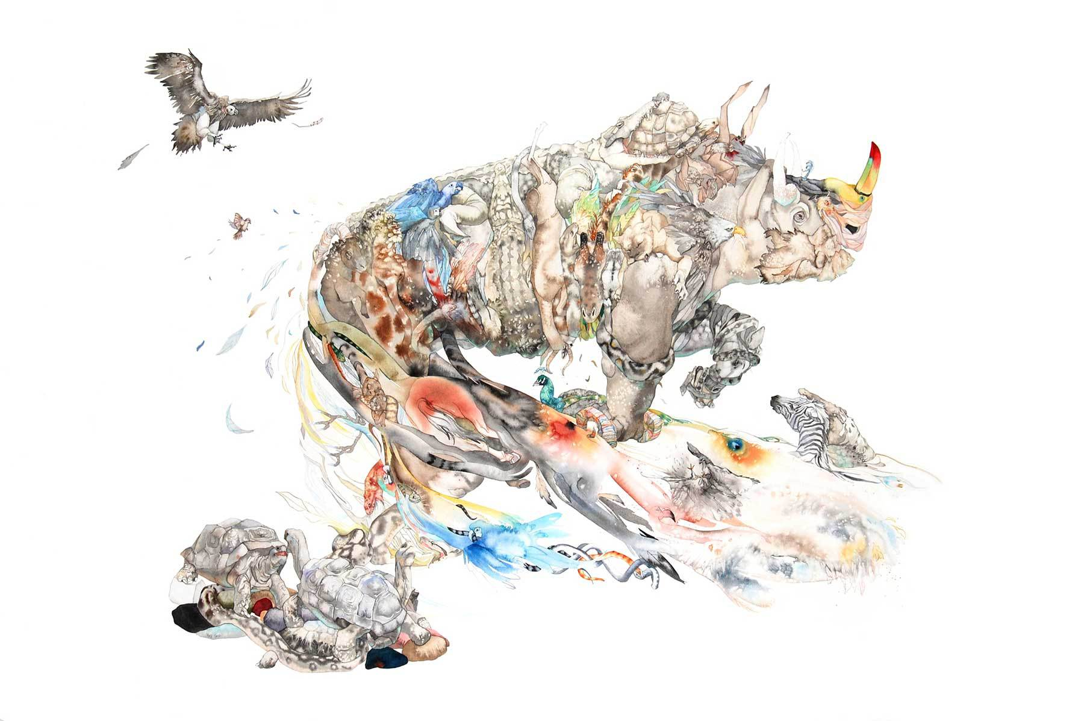

© Laura Ball

“Footing the Bill: Art and Our Ecological Footprint” is a two-part exhibition addressing the urgent need to live sustainably within the Earth’s finite resources. Part II of the exhibition launches on Earth Day 2016 (April 22), and features works from 35 artists by invitation only, including the work of Laura Ball. In her intricate watercolor paintings, Ball portrays a colorful tangle of creatures that weave their way into our consciousness. She charts a course through our dreams and memories to environmental values long neglected.

The exhibition offers the opportunity for active engagement on issues of sustainability. Each artwork in the online exhibition is paired with a series of “pledges,” actions that individuals can take in their own lives to reduce their environmental impact. Visitors who adopt one or more pledges will be able to share those pledges, along with an image of the artwork that inspired them, with their social networks on Facebook, Twitter, Google+ and Tumblr. The exhibition will be promoted with the hashtags, #EndOvershoot and #OneEarth.

“The ultimate objective of this exhibition is to create dialogue and inspire action. The interactivity and digital nature of this project makes it accessible to all audiences, which is
vital because while this issue affects us all, we also all have equal opportunity to act,” says Executive Director Randy Rosenberg.

About Art Works for Change:
Established in 2008 and incorporated in 2010, Art Works for Change strives to harness the transformative power of art to promote awareness, provoke dialogue, and inspire action. We seek to address issues of serious concern—human rights, social justice, gender equity, environmental stewardship and sustainability—in creative, inspiring, and ultimately positive ways. Our museum-quality exhibitions are amplified by local programming and global partnerships, and become a crucible where artists, museums, advocacy organizations, and local community unite as a collective force for change.

About Partnering Organizations:

Global Footprint Network is an international think tank that coordinates research, develops methodological standards and provides decision-makers with a menu of tools to help the human economy operate within Earth’s ecological limits.
Earth Day Network works year-round with thousands of partners worldwide to broaden, diversify and mobilize the environmental movement. Earth Day Network leads environmental campaigns, promotes green economic policies, educates the public and energizes communities to secure a healthy future for themselves and their children.
Oceana is the largest international advocacy organization focused solely on ocean conservation. With its science-based campaigns, Oceana seeks to win policy victories that can restore ocean biodiversity and ensure that the oceans are abundant and can feed hundreds of millions of people.
Environmental Defense Fund’s mission is to preserve the natural systems on which all life depends. Guided by science and economics, Environmental Defense Fund finds practical and lasting solutions to the most serious environmental problems.
TreePeople inspires, engages and supports people to take responsibility for the urban environment and to share the process as a model for the world. TreePeople works with the people of Los Angeles to plant and care for trees, harvest the rain, and renew depleted landscapes, creating a greener, shadier and more water-secure city at homes, neighborhoods, schools and in the local mountains.
For more information, please visit http://www.artworksforchange.org/footing-the-bill/.
Feel free to tweet @ArtWorks4Change, share on Facebook, post on Tumblir and Instagram (@artworksforchange), and check out AWFC on YouTube.

